**PIPES AND REDIRECTION OPERATION**

1. Create a script named “myscript” in current directory to do the following.

a) create a dir named “subd1” in current directory

**Ans:** **mkdir subd1**

b) create a file named “dircontent” with contents of the current directory

**Ans:** **ls>dircontent**

c) display the contents of the file “dircontent”

**Ans:** **cat dircontent**

d) display the contents of a non existing file named “unknownfile”

**Ans:** **cat unknownfile 2>/dev/null || echo “File ‘unknownfile’ does not exist”.**

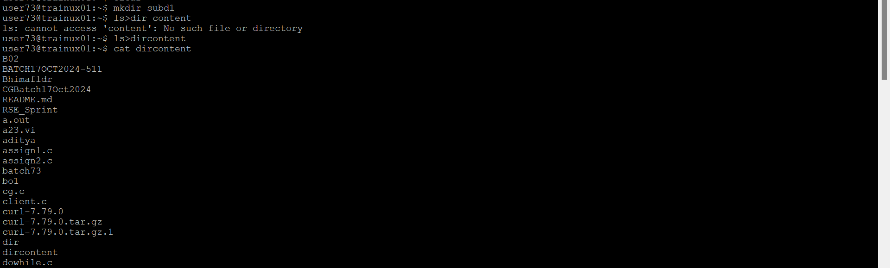

2. Run the script and validate the output in following cases

a) Redirect only the stdout to an o/p file named stdout.txt

**Ans:** **./myscript > stdout.txt**

b) Redirect only the stderr to an o/p file named stderr.txt

**Ans:**  **./myscript 2> stderr.txt**

c) Redirect both stdout and stderr to an o/p file named stdall.txt

**Ans:**  **./myscript > stdall.txt 2>&1**

d) Display all o/p and error and also redirect both stdout and stderr to an o/p file named stdall.txt

**Ans: ./myscript | tee stdall.txt**

3. Redirect the output of command below using pipe (|) to wc and get the output

**Ans:** **To redirect the output of the command ls -l, to wc using a pipe (|), you would use the following command:**

**ls -l | wc**